Environment Variable in Postman

The postman variable is similar to the programming language variable. As we know, a variable is an entity, which stores value. You can change the value of the variable. In [Postman](https://www.javatpoint.com/postman), a variable is a set of key-value pairs. Here the key is the variable and value is the value of the variable.

Creation Of Environment:

Just Click on Environments and Click on “+” to create new Environment variables.

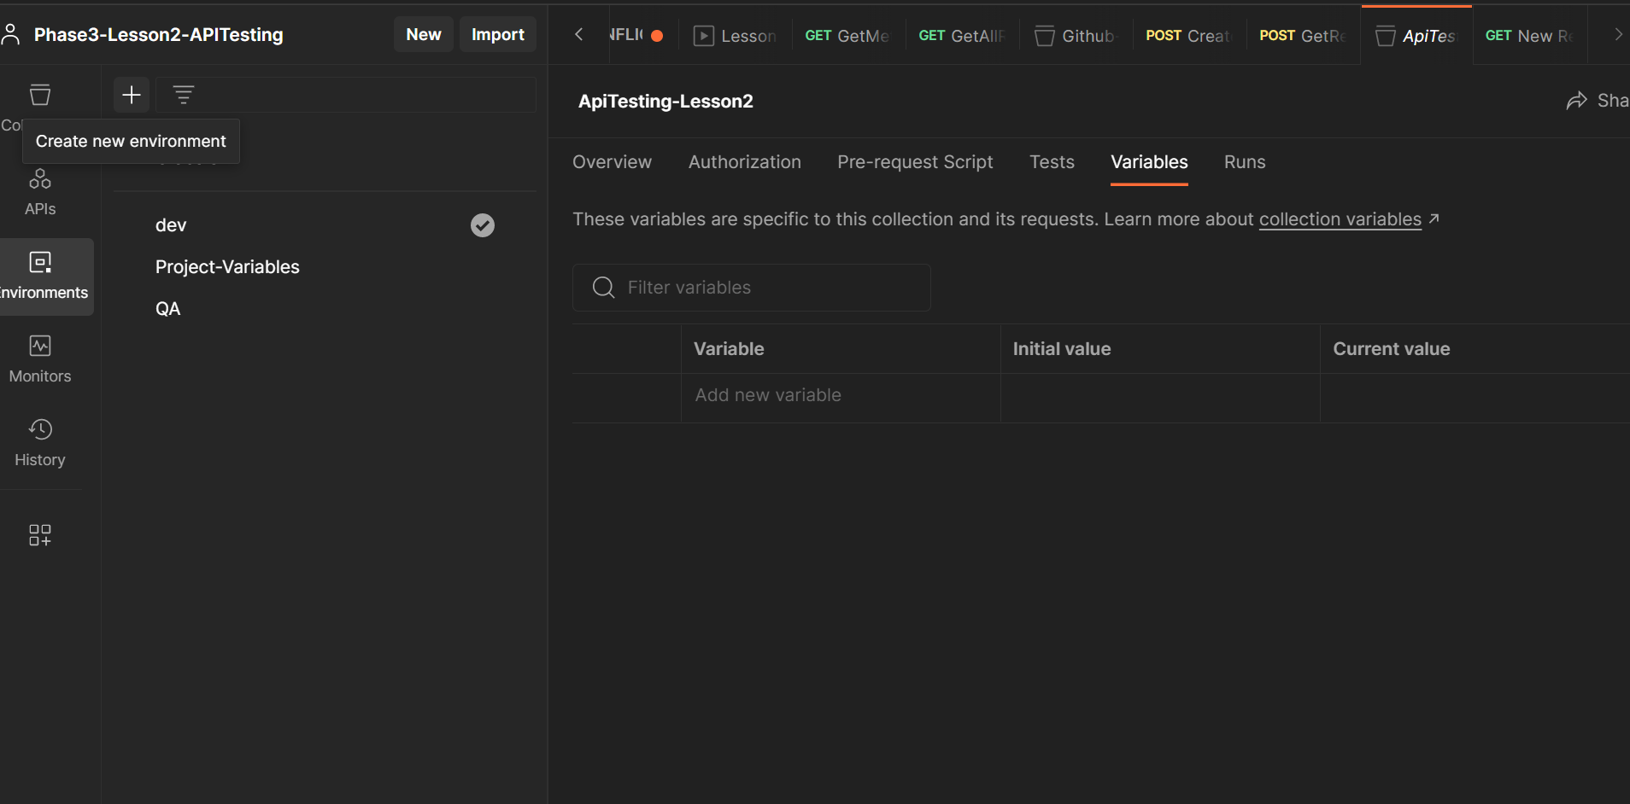

This Varaibles Used to run The POSTMAN . I used Dev variable and run the script.

